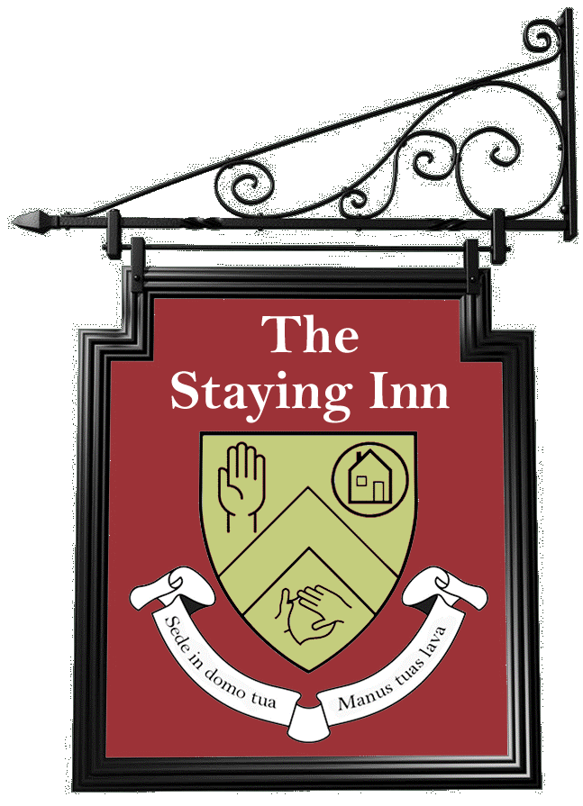
BBC Radio 5 live Interview transcript

Early on 30 April 2020

Amy: It started as a bit of a joke to be honest on my own dining table to be honest. I put up a silly sign saying The Staying Inn and was chatting to friends and family like everyone is over video call, but as I'm an online activist I got more and more requests to join in so I decided to open the pub properly.
Host: how many people have you got regularly attending then?
Amy: around 100 each week at the moment, we hope to grow more.
Host: is that about as much as Zoom can cope with at any one time?
Amy: It is yes, so we may have to invest to expand.
Host: yeh I would say so. And is it always focused around a quiz? How does it work?
Amy: so we have a weekly quiz on a Saturday at eight, and then we have different sessions on either a Wednesday or a Sunday, they often have a disability focus because that's a large cohort of the regulars. So for example on Sunday I'm talking to an Australian activist all about disability activism, and then next week we have a British Sign Language lesson.
Host: brilliant. So how do you make sure this is as accessible as possible then?
Amy: so Zoom is actually a really good software for accessibility, it's accessible to visually impaired people like myself because it works with screen reader technology. We also have live captions, so a service dials in and provides live subtitles to the call. And we have British Sign Language interpreters at the majority of our events.
Host: really really important service for people who are feeling isolated at the moment.
Amy: yeh definitely, I know you were talking about shielding earlier on, and realistically for a lot of disabled people and people with long term health needs, they're going to be stuck indoors for quite a while after everyone else can go back outside, so it's important we keep it going and that's why I'm trying to fundraise money.
Host: yeh, and people are in fact making connections through the virtual pub aren't they? People who didn't know each other before?
Amy: yeh, its really nice, like there's two ladies who are deaf who now meet up and have chats over video call. And it's just reaching a lot of really isolated people, I've had messages saying it's the first time someone's heard voices that week. It's kind of important to stay connected even though we're far apart.
Host: yeh, oh one hundred percent, and if its the first time you've heard voices outside your household or, you know, outside the radio or TV, then my goodness it does make a difference doesn't it?
END

